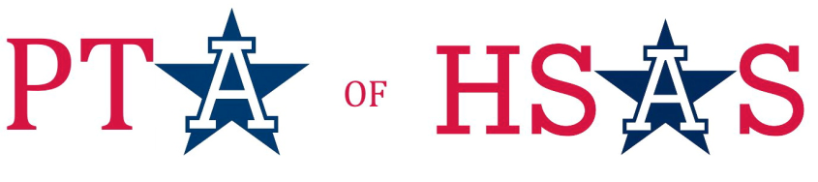

PTA of HSAS 2014 Spring Benefit

March 23, 2014

Dear Friend of HSAS,

The High School of American Studies at Lehman College (HSAS) is one of New York City’s most competitive public Specialized High Schools. Located in the Bronx, HSAS admits academically talented students from all five boroughs to its challenging program with an American history emphasis. Our international recognition is growing as educators from foreign countries are interested in our successful history-centric curriculum. US News and World Report perennially ranks our high school one of the top 10 in NY State, and one of the top 50 in the nation!

Yet the harsh reality is that the Department of Education (DOE) budget is simply not sufficient to cover all of the HSAS expenses. After salaries and administrative costs, the school will have little money to fund the essentials that our students need to complete their education. This year, due to unprecedented budgetary constraints, the PTA will be responsible for paying for items that were in the past part of the regular school budget. Essentials like school, science and art supplies; teacher compensation for afterschool activities such as teams, clubs, tutoring and chaperoning trips; sports equipment and uniforms; school trips; club and team expenses; technology needs. The list continues to grow.

We need your help now more than ever. The PTA of HSAS is holding its 3rd annual Spring Benefit and Auction on March 23, 2014, to raise funds that will help close the gap between what the DOE provides and what our students need to succeed. Please consider supporting our fundraising efforts by donating to our auction. Every donation is helpful!

Donating is easy. Simply fill out and return the enclosed Auction donation form by email to: hsaspta.auction@gmail.com, send via post to: PTA of HSAS Auction, High School of American Studies at Lehman College, 2925 Goulden Avenue, Bronx, NY 10468 or go to https://hsaspta.ejoinme.org/itemdonation to donate online.

By participating, all donors will be listed in all promotional materials, including print, website, event brochure and our online auction. With your permission, we will use your logo and website links as well. Please send your company logo to hsaspta.auction@gmail.com. Please contact us if you are interested in becoming a sponsor for our event.

On behalf of our students, teachers, administration and families – we thank you in advance for your generous support!

With gratitude,

The PTA of HSAS Benefit Committee

Questions? Contact hsaspta.auction@gmail.com

The High School of American Studies at Lehman College (HSAS) is a NYC Public School. All proceeds will directly benefit HSAS students. We affirm that no goods or services have been provided to you, in whole or in part, in consideration for your contribution.

The 501(c)(3) status of the PTA of HSAS is currently pending. Any contribution to the PTA of HSAS does not have advance assurance of deductibility
at this time. If the PTA of HSAS ultimately qualifies for 501 (c) (3) status, then any contributions made after May 5, 2013 will be deductible.
Alternately, if our tax exempt status is denied, then your contribution will not be deductible.

THANK YOU!

PTA of the High School of American Studies at Lehman College 2925 Goulden Ave., Bronx, NY 10468 718.329.2144 www.hsaspta.org
www.hsas-lehman.org

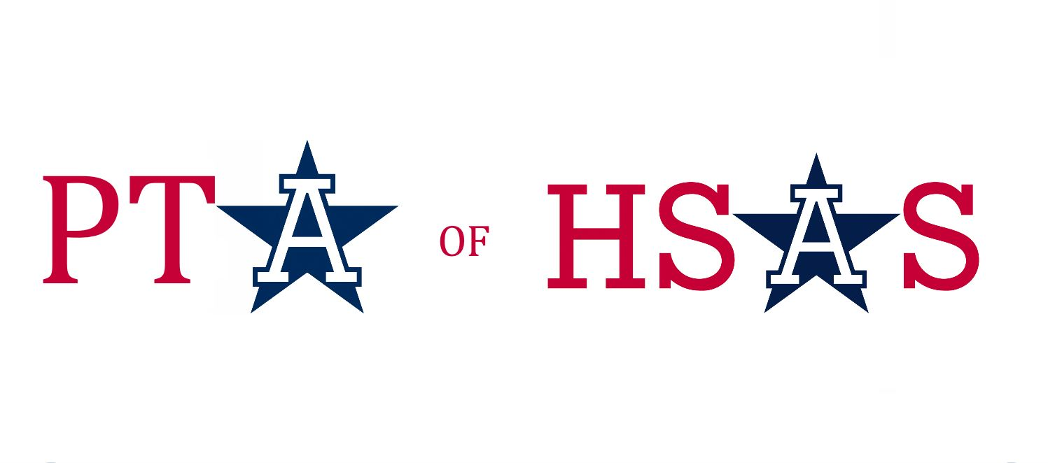

HSAS PTA 2014 Spring Benefit

March 23, 2014

Donation Form
DONOR INFORMATION:

Donor/Company Name: _________________________________________________________
(as it should appear in promotional materials)

Contact: ___________________________________ Email:____________________________

Address: _____________________________________________ Phone: ________________

Signature: _____________________________________________ Date: _______________

ITEM DESCRIPTION:
____________________________________________________________________________________________________________________________________________________________________________________________________________________________________________________________________________________________________________________
Fair Market Value: $ ____________
Choose one:
Donation is enclosed/attached _ Please generate a certificate from info on this form
______ I would like to be a sponsor for this event
Restrictions/ Expiration Date/ Remarks:
____________________________________________________________________________________________________________________________________________________________
Yes __ No Donation may be sold in PTA of HSAS online auction
Yes __ No PTA of HSAS can link item to your company website.

HSAS FAMILY CONTACT INFORMATION:

HSAS Parent: ____________________________ Cell: ________________________________
Parent email _________________________________________ Student Class in HSAS: ______

The HSAS PTA 2013 Spring Benefit is sponsored by the PTA of HSAS. All proceeds will directly benefit HSAS.
PTA of HSAS affirms that no goods or services have been provided to you, in whole or in part, in consideration for your contribution.

Questions? Contact hsaspta.auction@gmail.com. www.hsaspta.org www.hsas-lehman.org

THANK YOU!

PTA of High School of American Studies at Lehman College, 2925 Goulden Ave., Bronx, NY 10468

